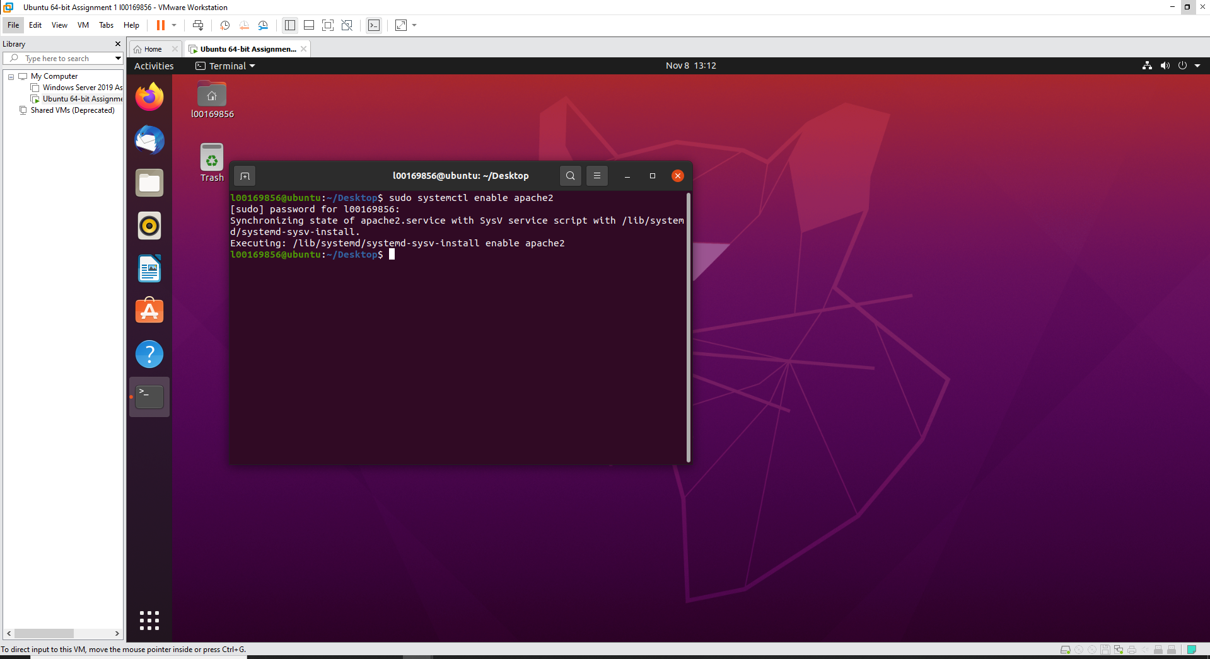

Enabling and installing Apache2 on the VM

Starting Apache 2 on the VM

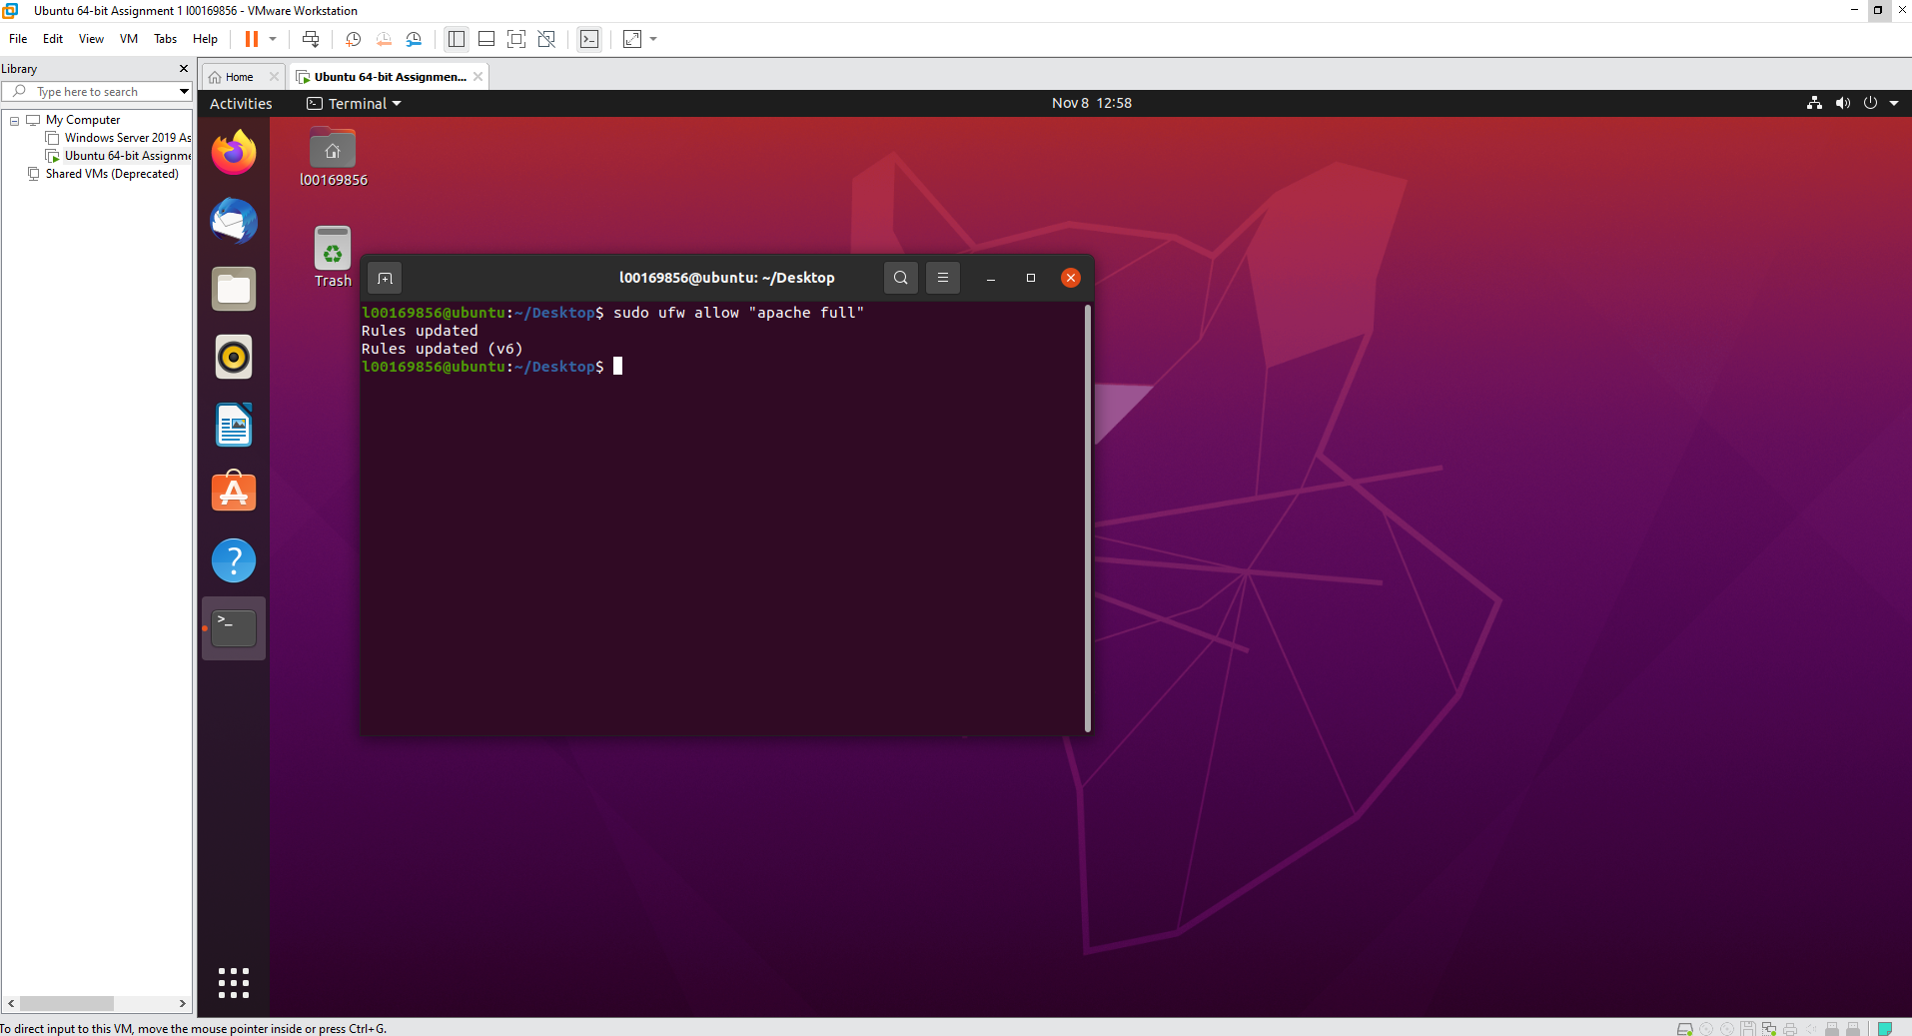

Allowing Apache2 through the firewall

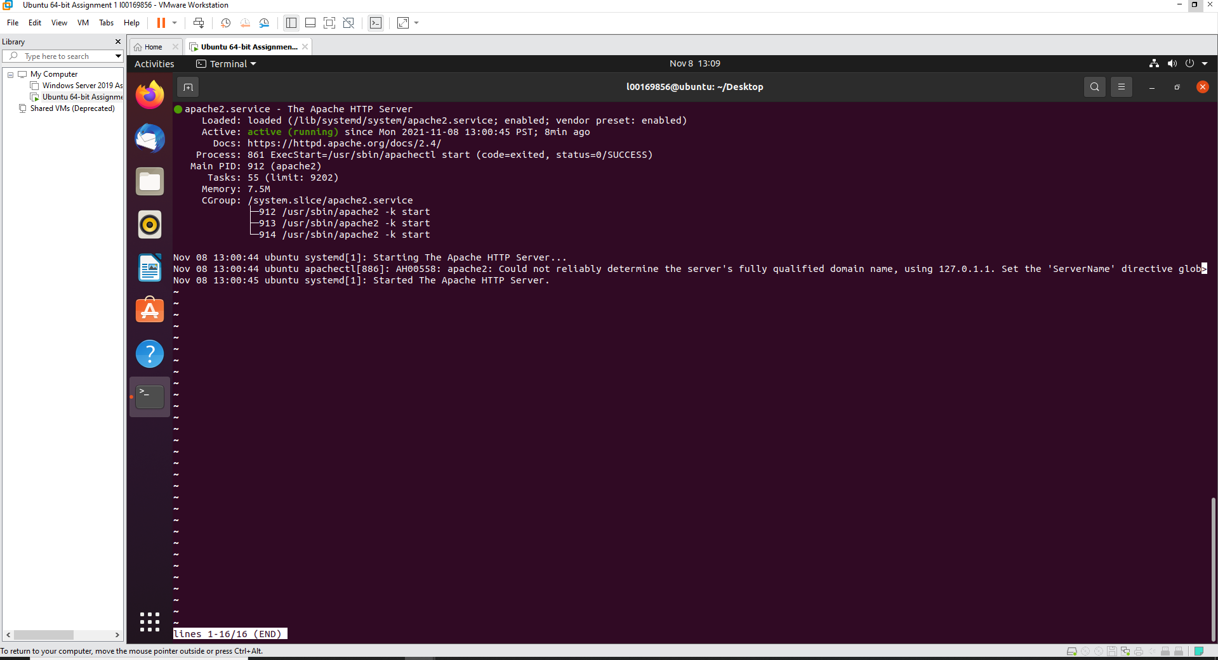

Checking the status of Apache2

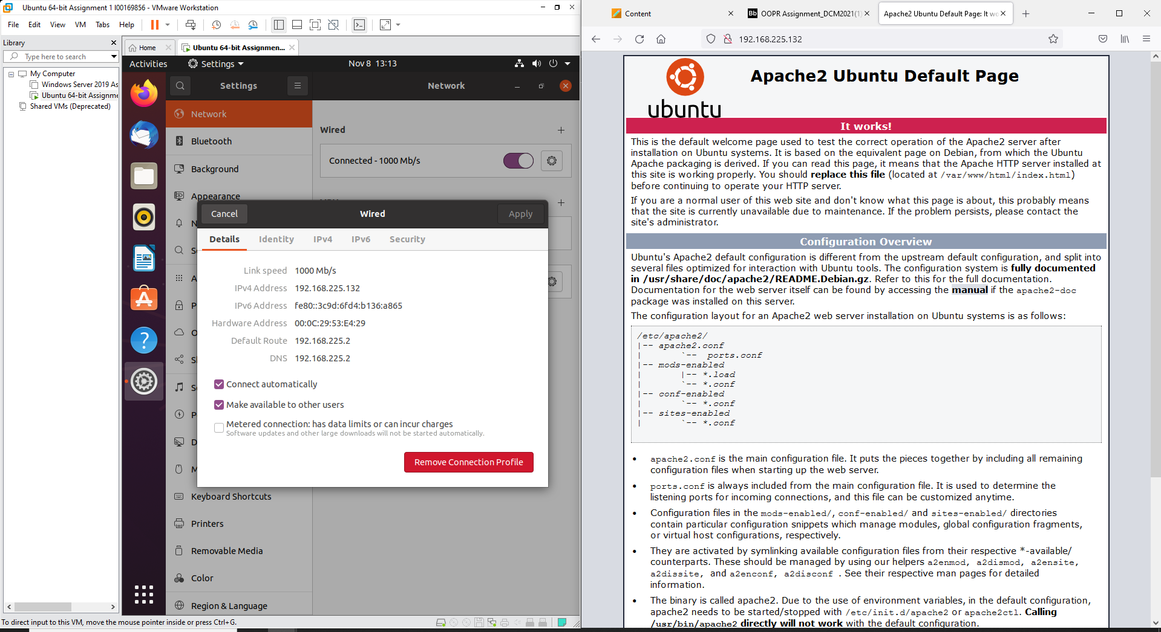

Apache2 webpage working using the same IP address as the VM